Fish-catch Prediction based on a
Mamdani-style Fuzzy Inference System

Purpose: As a very simple example presented in my proposed book, we discuss predicting the number of fish that will be caught based on a Mamdani-style FIS (Fuzzy Inference System). We’ll use that system here as an example, both of how to specify the details of a fuzzy logic-based design and of how to perform the detailed calculations relative to such a design. We’ll also consider several useful concepts relative to practical applications of fuzzy logic along the way. Note: We’re focusing here on how to implement the system once designed. For a detailed discussion of the process of designing this system, see Section 1.4 in the current draft of the new book.

Overall System Design:
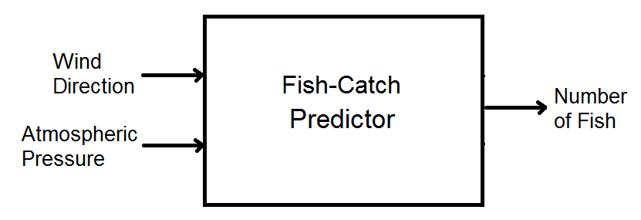

Two-input/one-output system:
Wind Direction (WD): Direction from which wind is currently blowing as degrees on the compass.
Atmospheric Pressure (AP): Current barometric pressure in hectopascals.
Number of Fish (NF): Predicted number of fish each angler will catch.

Term Sets:
T_{WD} = {N, E, S, W} (for north, east, south, and west)
T_{AP} = {low, average, high}
T_{NF} = {skunked, small catch, good catch, great catch}

Numerical Value Sets:
X_{WD} = [0, 360] X_{AP} = [900, 1100] Y_{NF} = {0, 1, 2, . . ., 11, 12}
Notice that we have continuous (infinite) sets of numerical values for the two inputs, a discrete and finite set for the output numerical values.

Fuzzy Relations:
We can illustrate the three fuzzy relations as Little Billy did in the book.

R_{WD}
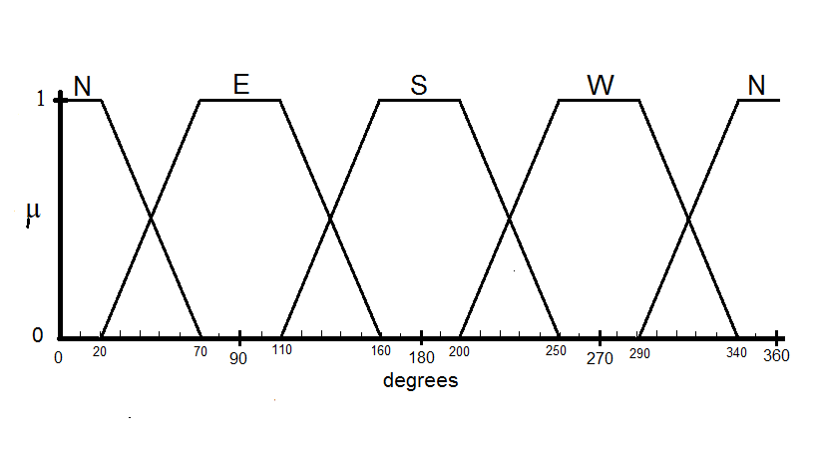

R_{AP}
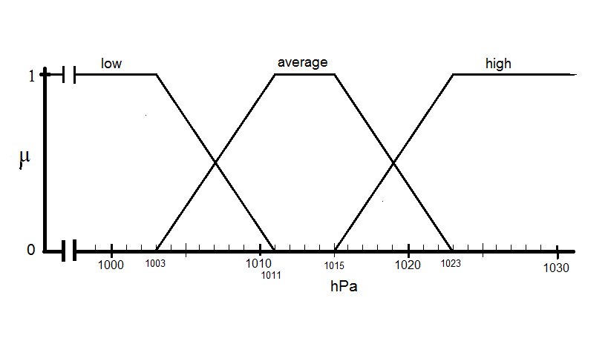
R_{NF}
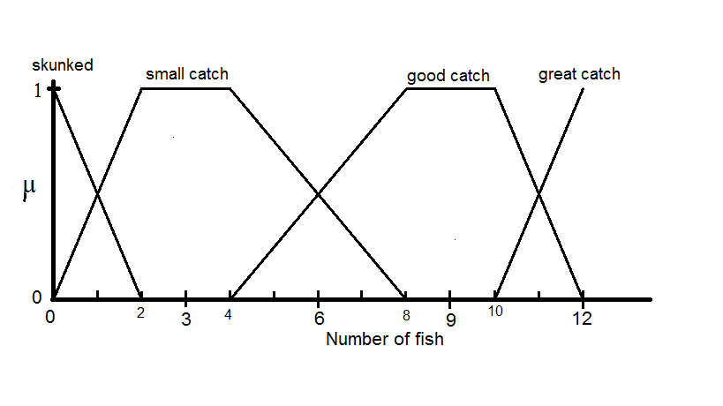
Both because it is not always easy to get exact values off of plots like these and because we eventually want to automate the calculations anyway, let’s stop here and think of another way to express these fuzzy relations. In the process of doing so, we’ll define a few more concepts related to fuzzy set theory and fuzzy logic generally.
Let’s start by talking a little about the definition of what is called a fuzzy number. There are more advanced versions of this concept, but here, let’s consider only one-dimensional fuzzy numbers. In this sense a fuzzy number is
a fuzzy subset of the set of all real numbers that is both normal and convex. In other words, a fuzzy number is a particular type of fuzzy set, that has the three characteristics. It is i.) defined on the real numbers, ii.) “normal”, and iii.) “convex”. But that leaves us with the need to define what we mean by normal and convex.
“Normal” is easy to define, but “convex” is a little tricky if we don’t want to get too far into other theoretical concepts right now. Any fuzzy set A, which is a subset of universal set X is said to be normal if there exists at least one element x  X such that μ_{A}(x) = 1. As for convexity, let’s us start by noting that what we mean by “convex” in this context may not be the same as how you normally define the term. For now, let us settle for a very informal definition: a fuzzy set that is not convex is one for which the membership function decreases for a certain range of values and then starts to increase once again.
One of the reasons it is useful to bring up the concept of a fuzzy number here is that it is usually assumed that in a FIS the fuzzy relations of the linguistic variables will be defined in such a way that each linguistic term corresponds with a fuzzy number. Note that for the various terms used in the design above, this is true in every case.
The membership functions of fuzzy numbers can take a variety of shapes. Some can be based on nonlinear functions (e.g. “bell curve”) and others are called “piecewise linear”. Among the piecewise linear fuzzy numbers, the two most common and basic of these are known as “triangular fuzzy numbers” (TFN) and “trapezoidal fuzzy numbers” (TrFN), although actually we could think of a TFN as a special case of a TrFN.
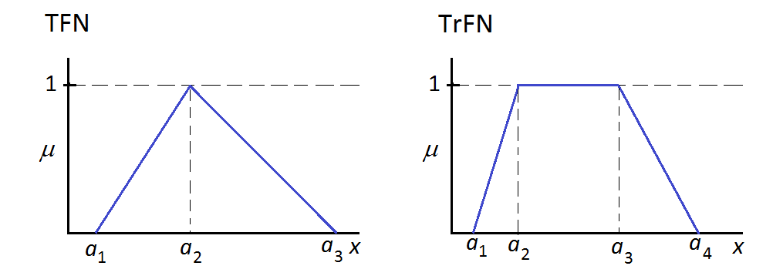
Note that if we decide from the start that we are working with triangular fuzzy numbers, any particular TFN can be uniquely identified by expressing three parameters (often, by custom, labeled a₁, a₂, and a₃, respectively). The first parameter tells us where the membership function departs from the x-axis, the second tells us where the function attains the value of 1, and the third tells us where it returns to the x-axis. (Note that the three values listed must be in non-decreasing order.) A TrFN can be uniquely identified by expressing its four parameters (customarily a₁ through a₄) the first being the departure point from the x-axis, the second being the point at which the function first attains the value of 1, the third is the last point at which it maintains the value of 1, and the fourth is the return point to the x-axis.
It is a simple matter of analytical geometry to come up with a general expression of the membership function for a TFN based on its three parameters. One way is:
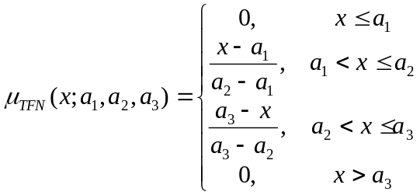
Try this out on your own. For example, consider the TFN with parameters (2, 4, 8). I often like to use a compact format for expressing this. In general:
does the job.
The situation for a trapezoidal fuzzy number is only slightly more complicated. Here, we can generally state:
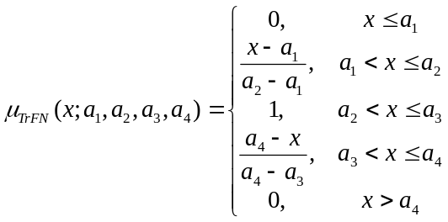
or more compactly as
.

All of this will be useful when we think about how we might eventually automate the FIS calculation process. And also the concept of using (3 or 4) parameters to express a TFN or TrFN gives us a convenient way to state our fuzzy relations. We can generally represent all our fuzzy relations in our fish-catch prediction case by saying that we are using trapezoidal fuzzy numbers and listing the parameters. However, there is a bit of a complication for wind direction in the sense that the compass wraps around (0○ becomes 360○) and this makes things trickier especially for the case of north.

R_{WD} : N : (-∞, 0, 20, 70) ⋃ (290, 340, 360, ∞)
E : (20, 70, 110, 160)
S : (110, 160, 200, 250)
W : (200, 250, 290, 340)
R_{AP} : low : (-∞, 900, 1003, 1011)
average : (1003, 1011, 1015, 1023)
high : (1015, 1023, 1100, ∞)

R_{NF} : skunked : (-∞, 0, 0, 2)
small catch : (0, 2, 4, 8)
good catch : (4, 8, 10, 12)
great catch : (10, 12, 12, ∞)

Fuzzy Inference Rules: As discussed previously, it is usually convenient to represent the inference rules in tabular form. In the case of a 2-input, 1-output system, we need just one table that is two-dimensional (i.e. a 2D array or matrix). In fact, another way to think of the linguistic rules is as a bivariate function:
f_{NF} : T_{WD} x T_{AP} → T_{NF}

For NF (the number-of-fish “algorithm”):
f_{NF}(t_{WD} , t_{AP})
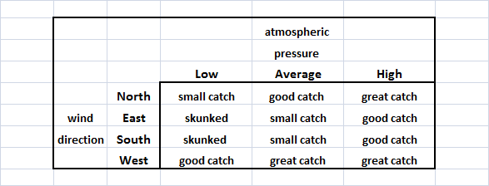

Operators to Be Used: Use standard fuzzy logic operators, max-min rule of fuzzy composition, and COG (center-of-gravity) defuzzification.

Numerical Example of Calculations:
Suppose as an example, we consider the case where the wind direction is 220○ and the atmospheric pressure is 1009 hPa. Using the fish-catch prediction system as designed, how do we predict the number of fish each angler will catch today?
For some people, the process of making calculations for a Mamdani-style FIS seems fairly obvious, but it is a somewhat complex process. My approach is to break down the process into the following four steps:

Step #1: Fuzzification of Inputs: We transform the crisp numerical inputs into fuzzy linguistic inputs based on the input fuzzy relations.
Step #2: Fuzzy Inference: We calculate fuzzy linguistic output(s) based on the fuzzy linguistic inputs we had from Step #1 and on the fuzzy inference rules.
Step #3: Fuzzy Output Quantification: We transform the fuzzy linguistic output(s) from Step #2 into fuzzy numerical output(s), based on the output fuzzy relation(s) and on a principle known as the Max-min Rule of Fuzzy Composition.
Step #4: Defuzzification of Outputs: We transform the fuzzy numerical output(s) from Step #3 into crisp numerical output(s), based on our previously chosen defuzzification method.

There is typically more than one way to think about each step and more than one way to represent the calculations. In each case, there is usually a fairly easy way for us to think of how to do the calculations manually and another way to think of the how to automate the calculations when we actually implement the system in a machine. We’ll take it step by step and consider some different ways on each step.

Step #1: Fuzzification of Inputs: The point here isn’t really to fuzzify the inputs for the sake of fuzzifying them. Rather, it is to express the inputs in a more linguistic way so that we can apply the inference rules to them. It just happens that since we are working with fuzzy relations, the inputs become fuzzified as a result of translating them into the linguistic realm. For many people, this seems to be the easiest step. When doing the calculations manually, a graphical approach is generally the easiest way to figure out what is going on, though unless we have plotted the fuzzy relations very carefully, it might seem difficult in some cases to get the exact results this way. We can then combine what we can see from the plots with a little analytical geometrical analysis to get the exact result.
On the other hand, we can also go back to our analytical expressions of the membership functions that make up our fuzzy relations, and this will probably be the way we would need to think if we were going to automate the process. Just to start with one nice example, consider that for the first input, x_{WD} = 220 (we’ll later just call it WD), and that in the case of wind direction = S, we have the four parameters a₁ = 110, a₂ = 160, a₃ = 200, and a₄ = 250, so we can calculate:
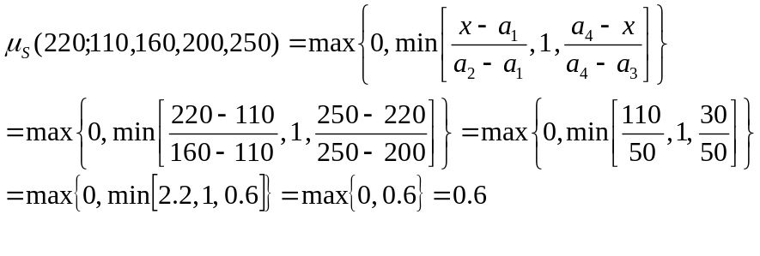
Similarly: 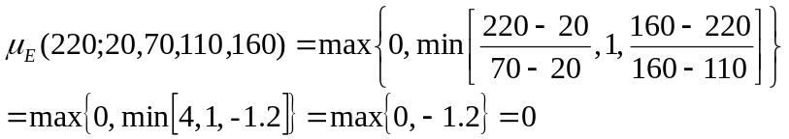
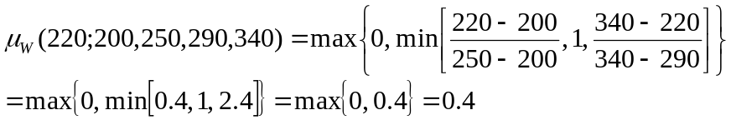
We are faced with the peculiar case for north, since the compass wraps around. So we’ll do the calculations for each part and take the maximum of the two.
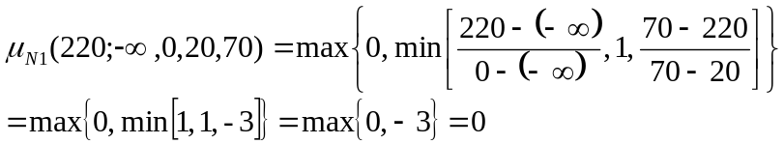
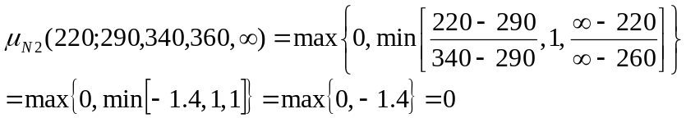
Obviously then, since we ended up getting zero for both versions of north with 220, the maximum of the two will also be zero.
One way of summarizing these results for the fuzzy linguistic form of the variable wind directions would be
μ_{N}(x_{WD}) = 0, μ_{E}(x_{WD}) = 0, μ_{S}(x_{WD}) = 0.6, and μ_{W}(x_{WD}) = 0.4,
but if we were to think of this in a slightly different way, we’ll no longer consider the terms north, east, south, and west (or N, E, S, and W) be fuzzy sets in themselves, but rather as simply the elements of the universal set T_{WD}. And we’ll think of the fuzzy linguistic form of the input wind direction to be a fuzzy subset of T_{WD}. We’ll call this here WD’. Thus, here we would say instead that
μ_{WD’}(N) = 0, μ_{WD’}(E) = 0, μ_{WD’}(S) = 0.6, and μ_{WD’}(W) = 0.4,
or using the strange sort of notation: WD’ = 0.6/S + 0.4/W.

Naturally, we can perform similar calculations to determine AP’.

This leaves us with
μ_{AP’}(low) = 0.25, μ_{AP’}(average) = 0.75, and μ_{AP’}(high) = 0,
or more concisely, AP’ = 0.25/low + 0.75/average.
So we have now completed Step #1. We might represent how far we have come by the diagram below.
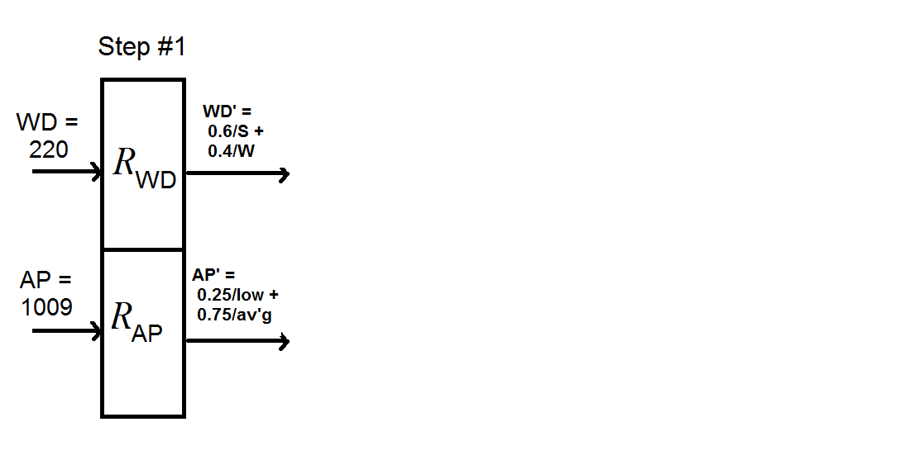

Step #2: Fuzzy Inference: This is where we apply the actual linguistic inference rules (which in the case of a fuzzy control application might be called the control rules) subject to the fuzzy linguistic input values we had from Step #1. As a result we’ll get the output(s) also, for now, in a fuzzy linguistic form. It is a particularly significant step, and not so difficult to understand. There is a shortcut method for doing the calculations manually, but for now let’s start by analyzing how we can apply the inference rules to fuzzy inputs.
We go back to our inference rules (we can call them the number-of-fish “algorithm”) which we agreed we could summarize in the form of a table:

But we also know we could express the rules explicitly in a production rule format. One way would be to have one rule for every possible combination of linguistic input terms, which in this case would leave us with 12 rules:
Rule #1: IF WD = north AND AP = low THEN NF = small catch.
Rule #2: IF WD = north AND AP = average THEN NF = good catch.
.
.
.
Rule #12: IF WD = west AND AP = high THEN NF = great catch.
Notice that in each of the rules, we used conjunction (“AND”) but we never used disjunction (“OR”). Suppose now that we allow ourselves to use disjunction too, and replace the 12 fairly simple rules above with a smaller number of slightly more complex rules:
Rule #1’: IF (WD = east AND AP = low) OR (WD = south AND AP = low)
THEN NF = skunked.
Rule #2’: IF (WD = north AND AP = low) OR (WD = east AND AP = av’g)
OR (WD = south AND AP = av’g)
THEN NF = small catch.
Rule #3’: IF (WD = north AND AP = av’g) OR (WD = east AND AP = high)
OR (WD = south AND AP = high)
OR (WD = west AND AP = low)
THEN NF = good catch.
Rule #4’: IF (WD = north AND AP = high) OR (WD = west AND AP = av’g)
OR (WD = west AND AP = high)
THEN NF = great catch.
We could end up with only four rules because we collected and merged all the rules that related to each of the four linguistic terms associated with the number-of-fish variable. This is an ideal format for expressing how we might apply the fuzzy logic operators to the situation.
Recall that when we talked about fuzzy set theory, we considered that there might be more than one way to represent set intersection, but what we would consider to be the standard fuzzy set operator for intersection would be to take the minimum of the two component membership grades. Similarly, there are other possible ways to define set union, but what we would consider to be standard would be to take a maximum.
In an exactly analogous way (we could even say “isomorphic way”) in fuzzy logic there are other possible ways to represent conjunction (“and”) but we’ll consider the standard conjunction operator to be taking the minimum. For fuzzy disjunction (“or”) again there are multiple possible ways, but the standard disjunction operator will be taking a maximum of the component parts.
Now it is quite easy to see how this would relate to the four rules above. Every time we see “AND” in a rule, we’ll think of taking a minimum, and every time we see “OR” we’ll think maximum. So
Rule #1’: IF (WD = east AND AP = low) OR (WD = south AND AP = low)
THEN NF = skunked.
can be interpreted as:
From Step #1, we just said that for this numerical example,
WD’ = 0. 6/S + 0.4/W, by which we mean
μ_{WD’}(N) = 0, μ_{WD’}(E) = 0, μ_{WD’}(S) = 0.6, and μ_{WD’}(W) = 0.4.

And also from Step #1, we said AP’ = 0.25/low + 0.75/average, so
μ_{AP’}(low) = 0.25, μ_{AP’}(average) = 0.75, and μ_{AP’}(high) = 0.,

Now all we have to do is substitute the appropriate values into the equation above to calculate:

The other rules are just a little more tedious in the sense that they have more “OR” clauses and thus a few more minima to take the maximum of, but we can follow them in a very similar way:
Rule #2’: IF (WD = north AND AP = low) OR (WD = east AND AP = av’g)
OR (WD = south AND AP = av’g)
THEN NF = small catch.
implies that

From
Rule #3’: IF (WD = north AND AP = av’g) OR (WD = east AND AP = high)
OR (WD = south AND AP = high)
OR (WD = west AND AP = low)
THEN NF = good catch.
we have

Finally, from
Rule #4’: IF (WD = north AND AP = high) OR (WD = west AND AP = av’g)
OR (WD = west AND AP = high)
THEN NF = great catch.
we determine:

So, what we have for the only output from Step #2 (the fuzzy linguistic form of the number-of-fish linguistic variable) is just
μ_{NF’}(skunked) = 0.25, μ_{NF’}(small catch) = 0.6,
μ_{NF’}(good catch) = 0.25, and μ_{NF’}(great catch) = 0.4,

or in another format,
NF’ = 0.25/skunked + 0.6/small catch + 0.25/good catch + 0.4/great catch.

In class, we’ll also discuss a short-cut method that is convenient when doing the calculations manually.

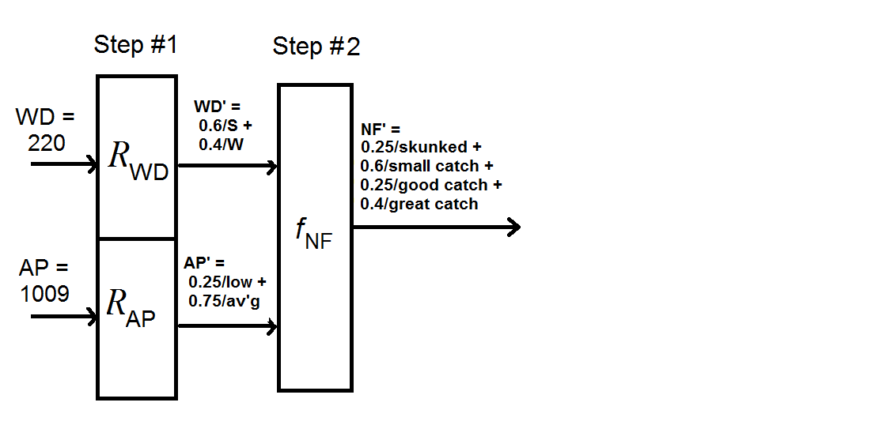

Step #3: Fuzzy Output Quantification: The last two steps may seem a little more difficult than the first two. The point of Step #3 is to take the fuzzy linguistic output(s) from Step #2 and convert it (them) into fuzzy numerical output(s), based on the output variable fuzzy relation(s). The reason this is a little tricky is that we are starting with a fuzzy set and a fuzzy relation and getting a different fuzzy set out as the result.
The main principle underlying how we handle Step #3 and similar situations is what is known as the Max-min Rule of Fuzzy Composition. This principle can be applied whenever we are trying to determine the composition of two fuzzy relations or (as we are going to do here) the composition of a fuzzy relation and a fuzzy set. In the long run, if you are interested in learning both the theory and the practice of using fuzzy logic, it will be useful for you to study up on how to apply this principle in general, but for lack of time, let us focus here primarily on how it applies to our particular situation.
In terms of what it says about how to calculate the fuzzy quantitative form of the number-of-fish linguistic variable, the Max-min Rule of Fuzzy Composition says the following.
Just as a reminder, T_{NF} = {skunked, small catch, good catch, great catch} is the set of all linguistic terms associated with this variable, and Y_{NF} = {0, 1, 2, . . ., 12} is the set of all numerical values associated with the variable. So for each possible numerical value y  {0, 1, 2, . . ., 12} for NF, we calculate μ_{NF”}(y) as shown in the equation. But since {0, 1, 2, . . ., 12} is a finite set (and a fairly small one at that), it turns out that there are a variety of convenient ways to think about this. One possibility is to represent it graphically. Before getting to that though, let’s review a little more about what the equation means.
We are just using t to represent one of the possible linguistic terms. So at any given moment, t can represent skunked, small catch, good catch, or great catch. In the same way, y, as we already said represents the particular value from Y_{NF} (the integers from 0 to 12) that we are considering at the moment. Thus, in any particular instance, y can be an integer from 0 to 12. The notation μ_{NF’} (t) we know just means the membership degree by which term t was represented in our results from Step #2. Thus, in our example, we know
μ_{NF’}(skunked) = 0.25, μ_{NF’}(small catch) = 0.6,
- μ_{NF’}(good catch) = 0.25, and μ_{NF’}(great catch) = 0.4.
By the notation μ_{RNF}(t, y) what we mean is how well does that particular term t relate to that particular numerical value y according to the way we defined R_{NF} when we first designed the system. We can remind ourselves of what this fuzzy relation is either by looking back at its graphical representation at the bottom of p. 2 or its parametric expression (based on the assumption of TrFN’s) near the top of p. 5. Just as one example out of the 52 examples we could consider, note that we might say μ_{RNF}(small catch, 5) = 0.75, in other words, the linguistic term small catch relates quite well (to degree 0.75) to the numerical value 5.
Now, what are the “Max” and “min” parts of the equation telling us to do? For a particular value of y, we are supposed to look at all (in this case all four) possible values of t, in each case taking the minimum of μ_{NF’} (t) (i.e. that term’s membership grade in the results from Step #2) and μ_{RNF}(t, y) (i.e. how well that term relates to that numerical value in our fuzzy relation). Then we take the maximum of those four minima.
We repeat this calculation across all values of y  Y_{NF}, and since in this case Y_{NF} is a finite set, we can explicitly enumerate them all. Even so, it still might be convenient to think of this step graphically at first and think of y almost as though it were continuous. So, what then is the graphical interpretation of what all the max-ing and min-ing in the Max-min rule? Well, once we think this through, it will seem relatively easy.
Let’s start by going back to look at the original graphical representation of this fuzzy relation.
R_{NF}
Now suppose we consider what min[μ_{NF’} (t), μ_{RNF}(t, y)] means if we consider the case of t = skunked and consider all possible values of y. As we can see from the graph μ_{RNF}(skunked, y) does take positive values where 0 ≤ y < 2, but that it always equals zero for y ≥ 2. For the other piece, in the results we got from Step #2, μ_{NF’} (skunked) = 0.25, and this is true no matter what y is. For y ≥ 2, min[μ_{NF’} (skunked), μ_{RNF}(skunked, y)] = min[0.25, 0]= 0, so the part that is a little more interesting is where 0 ≤ y < 2. If we were to pretend for the moment that y could take any real value (rather than just integer values) from 0 to 12, then we would say that for 0 ≤ y < 2, μ_{RNF}(skunked, y) = 1 – 0.5y. Notice that (still pretending for the moment that y takes real values) in the range 0 ≤ y < 1.5, μ_{RNF}(skunked, y) = 1 – 0.5y > 0.25 = μ_{NF’} (skunked). This means that for the range 0 ≤ y < 1.5, min[μ_{NF’} (skunked), μ_{RNF}(skunked, y)] = 0.25, but for the range
0.5 ≤ y < 2, min[μ_{NF’} (skunked), μ_{RNF}(skunked, y)] = 1 – 0.5y.
We can conclude then that for our example, if y could take any real value from 0 to 12 (even though it is really only defined for the integer values in that range), then the following would be true.
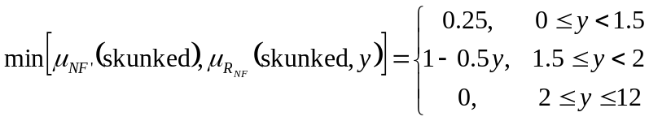
What does it look like to plot this? It has the effect of truncating (chopping off the top part above 0.25) of the membership function for skunked. (This is one graphical example of how the “min” part of the max-min rule works.) We’ll indicate this by the shaded yellow part of the modified plot below.
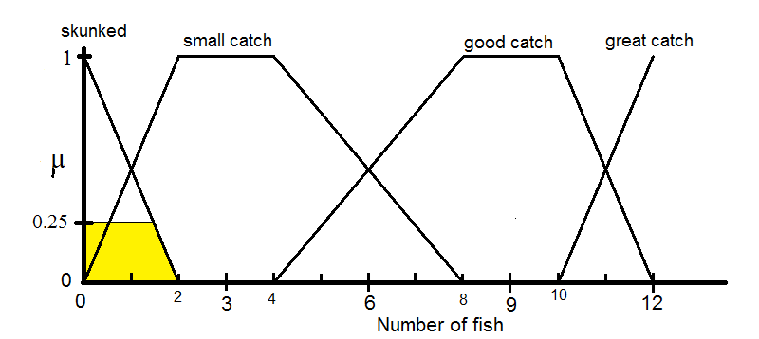

If we were to analyze the situation where t = small catch in a similar way, we would truncate the small catch membership function, but this time at the level of μ = 0.6, since in our example, we had from Step #2 that μ_{NF’} (small catch) = 0.6.
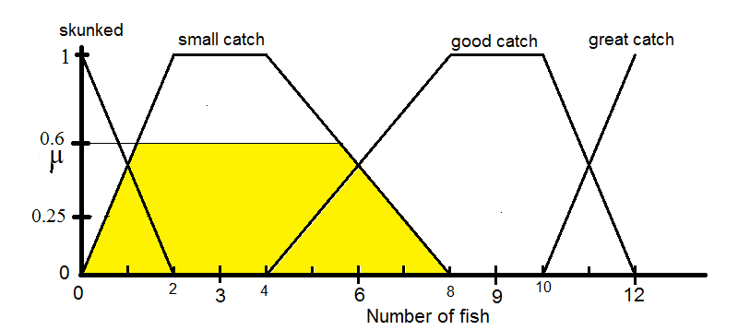
Similarly, we truncate the membership function for good catch at
μ = μ_{NF’} (good catch) = 0.25
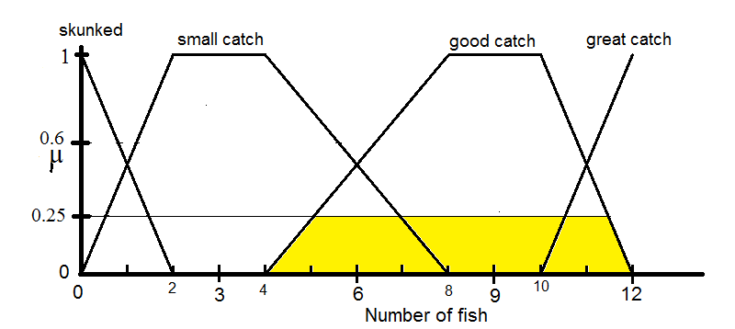
And for great catch, since μ_{NF’} (great catch) = 0.4, we have
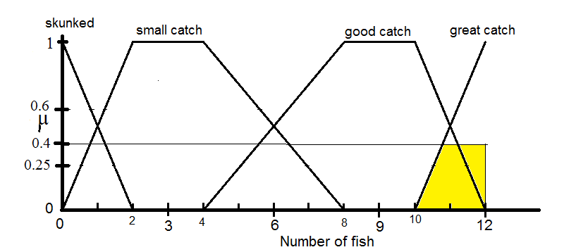

Now if we continue with this graphical interpretation a little more, the next question is how to put all this together. This relates to the “max” part of the max-min rule. What we’ll do graphically is combine each of these plots in such a way that we are taking the highest of the parts in yellow.
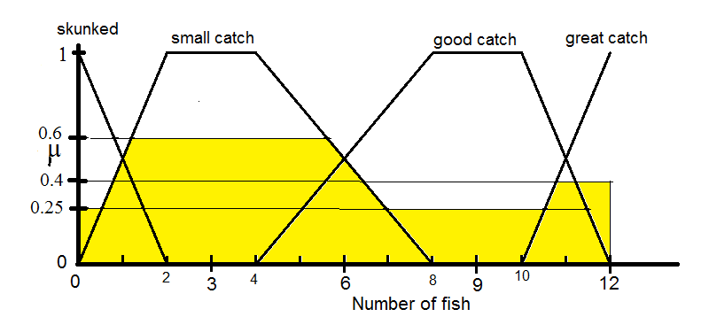
And at this point we can go back to thinking that Y_{NF} actually equals just the integers from 0 to 12 (not the reals from 0 to 12). And we can then read the fuzzy numerical output NF” from the integer values on the plot above.
NF” = 0.25/0 + 0.5/1 + 0.6/2 + 0.6/3 + 0.6/4 + 0.6/5 + 0.5/6 + 0.25/7 + 0.25/8 + 0.25/9 + 0.25/10 + 0.4/11 + 0.4/12.
This graphical interpretation is useful for understanding the max-min rule, and it may sometimes be the easiest way to do the calculations manually. However, especially where we have a finite numerical value set for the output variable, and where we want to automate the calculation for Step #3, it is sometimes better to think of these calculations in another way. First, in this context, consider that we could represent the fuzzy relation μ_{RNF} fairly easily in a tabular format.
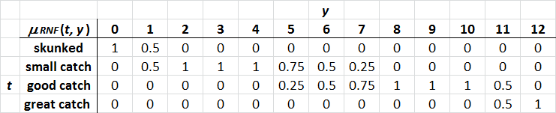
This makes it easier to understand how to apply the max-min rule in a direct way. Recall also that our results from Step #2 were
μ_{NF’}(skunked) = 0.25, μ_{NF’}(small catch) = 0.6,
- μ_{NF’}(good catch) = 0.25, and μ_{NF’}(great catch) = 0.4
and we have all we need to substitute directly into the formula,
Keep in mind, that we much calculate this for each y in Y_{NF} = {0, 1, 2, . . ., 12}, meaning that we have to go through thirteen calculations. We’ll start with the case of y = 0.
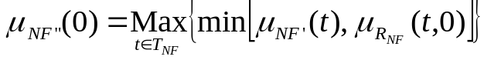
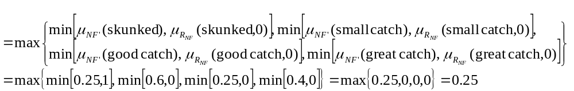Let’s look at a few more values of y as examples. For y = 1, we have the following.
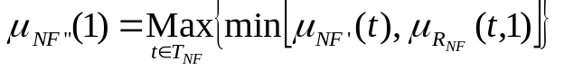
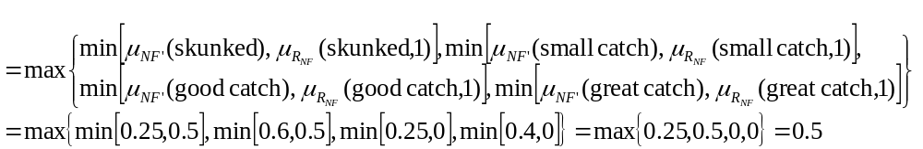
Next consider the case of y = 2.
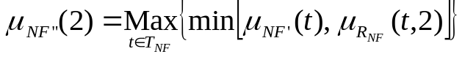
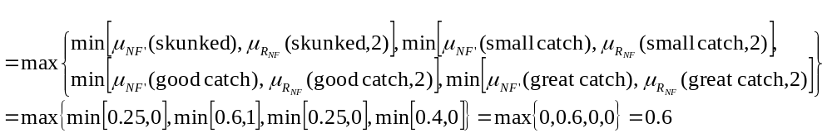
We could repeat the calculations in a similar fashion for the other ten values of y, and we would end up with exactly the same results we had for the graphical approach. It may already be somewhat obvious to you how we would automate this process more completely, but we will come back to this later. In any case, we end up with these same results for Step#3:
NF” = 0.25/0 + 0.5/1 + 0.6/2 + 0.6/3 + 0.6/4 + 0.6/5 + 0.5/6 + 0.25/7 + 0.25/8 + 0.25/9 + 0.25/10 + 0.4/11 + 0.4/12.
And we have now worked our way through three out of the four steps.we have now worked our way through three out of the four steps.
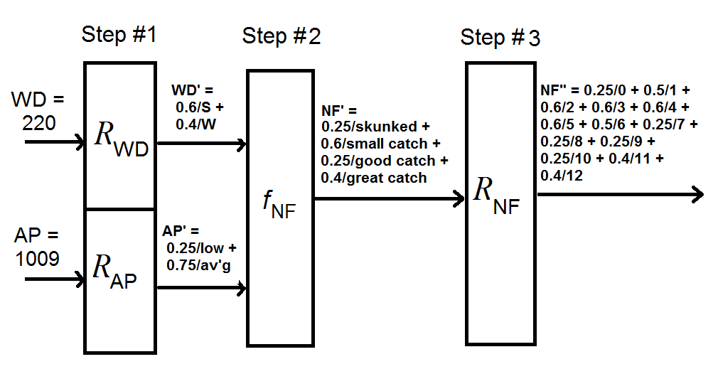

Step #4: Defuzzification of Outputs: In this step, we take the fuzzy quantitative (numerical) output(s) and turn it (them) into crisp quantitative output(s). This is where we have made life easier for ourselves by defining Y_{NF} to be a discrete set because it means we can use the discrete form of center-of-gravity (COG) defuzzification. This uses summation signs where continuous form of the same defuzzification scheme would use integral signs. (The integrals might be relatively easy, and maybe we could use the practice of some integral calculus, but discrete is generally going to be easier.)
Discrete COG defuzzification (there are defuzzification schemes other than COG, but COG is the most popular) for this example would rest on the following format.
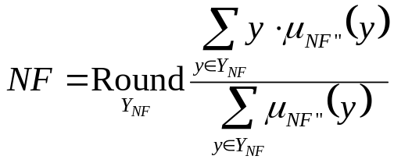

Some aspects of the notation here are my own, slightly unconventional, format. What I mean by the  is that after calculating the fraction, we should round off the quotient to the nearest value in Y_{NF}, which here means the closest of the integers between 0 and 12. It is a more broadly applicable format to write the summations as 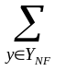although in this particular case, they could also be written as 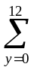and it would mean the same thing here. Essentially what we are doing in the discrete COG is taking a weighted average of the y values (weighted based on their memberships) and rounding off that average.
Well, let’s do the calculations for Step #4 for our particular numerical example. Remember that what we had from Step #3 was the following.
NF” = 0.25/0 + 0.5/1 + 0.6/2 + 0.6/3 + 0.6/4 + 0.6/5 + 0.5/6 + 0.25/7 + 0.25/8 + 0.25/9 + 0.25/10 + 0.4/11 + 0.4/12
Therefore we calculate in this way
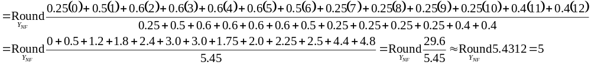
The name COG is indeed appropriate in the sense that if we think of cutting the plot we had from the graphical interpretation of Step #3 out of plywood, or some similar material of uniform thickness and density, and then found the center of gravity for that cut-out, we would have the right idea. Actually though the idea isn’t to find all the coordinates of the actual center-of-gravity in the 2D or 3D sense, but rather to find the single coordinate along the horizontal axis of our plot. Thus we could think of this as a problem similar to finding the balancing point of a teeter-totter (seesaw). It is a fun exercise to derive the formula from this point of view, but we’ll leave that for another time.


In previous versions of this class, I focused on examples with continuous numerical value spaces for the output variables, and asked the students to work through the integrals for the actual analytical solutions. It might be better though to start with discrete cases. In any case, after running through all four steps in our approach to calculating a Mamdani-style FIS, we end up with the following synopsis.
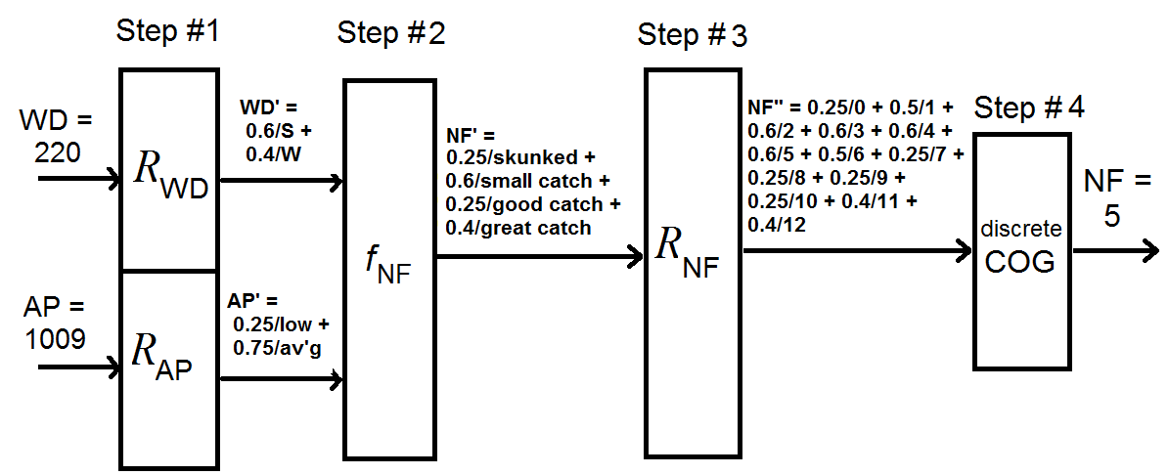
HW #3: Given the same design for a fish-catch prediction scheme as specified above, calculate the prediction for number of fish caught given that the current wind direction is 30○ on the compass and the atmospheric pressure is 1020 hPa.

Some Points Relating to Implementing Variations in FIS Designs and on Computer Implementation: Starting with the fairly simple example of the fish-catch prediction was a good way to understand many of the concepts of how to do calculations for a Mamdani-style Fuzzy Inference System. However, there are two important aspects of extensions we should make to what we saw there. First, we need to think about what would be different in slightly more complex designs. Second, we should think a little more about how to implement FIS calculations on the computer. These two topics are somewhat interrelated.
The fish-catch prediction FIS has two inputs and one output. The numerical value space for the output is discrete, and in fact fairly small with only thirteen possible values. On the one hand, there are many practical applications that are no more complex than this one, but on the other, there are many more that are slightly more complex in terms of at least one of these factors.
Much of what we discussed up until now relative to the calculation process and our numerical example for a Mamdani-style FIS has assumed that we are making the calculations manually or in a semi-automated way. We did mention already though that there nearly always are multiple ways to interpret and calculate each of the steps, and at times we hinted at what might be the more practical approaches when automating each step. It is useful here to mention a few more general points that relate to computer implementation, while still not going so far as to turn this into a programming class per se.
In my book on fuzzy control, I go into quite a bit more detail than I do here on how to implement the design and calculations in the form of computer programs written in typical general-purpose programming languages. Especially in Appendix B, I show considerable detail in how a typical design might be implemented in the form of a program in the Pascal language.

Multiple Outputs: In terms of considering a little more complexity, what would be different if we had more than one output? To continue with the same example, suppose we still wanted to predict the number of fish each angler would catch, and in addition to that, we also wanted to predict the size of the largest fish that would be caught. This would turn our two-input/one-output system to one that was two-input/two-output. What then would be different about the design of the FIS and what would be different in how we would do the calculations. We would still probably have all the same aspects of the design we already have (the two input linguistic variables, wind direction and atmospheric pressure, the output linguistic variable we already have for number of fish, and the set of inference rules we also have for number of fish) but we would just add to that. We would need to treat size of largest fish as a linguistic variable, meaning that we would have to define a linguistic term set for it, a numerical value space for it, and a fuzzy relation to join the linguistic to the numerical. Additionally, we would have to define a second set of inference rules. If stated in if-then format, this would mean another set of twelve rules, or if stated as a table, it would be a second 4x3 table. Although it is a slightly unusual use of the term, Mamdani started the custom of referring to this as our second “algorithm”. Thus, we would say that our expanded FIS has two algorithms—a number-of-fish algorithm and a size-of-largest-fish algorithm. Suppose we abbreviate the second as SLF.
In terms of how the calculations would work on such a design, Step #1 would remain exactly the same as before, but Steps #2 through #4 would each have two parts. In the revised Step #2 would use the WD’ and AP’ fuzzy linguistic inputs from Step #1 along with the now two algorithms to calculate the two fuzzy linguistic outputs—NF’ and SLF’, respectively. In Step #3, we’d use the output fuzzy relations to convert these into the two fuzzy numerical outputs—NF” and SLF”. In Step #4, we would defuzzify each of these to get our final crisp numerical predictions—NF and SLF.

Three or More Inputs: Some students become a bit confused when they decide to include more than two inputs for their designs, but it is not really much harder at all. Suppose that in addition to wind direction and atmospheric pressure, we decided to include water temperature (call it WT) in our design. Obviously, we would need to add this to the collection of linguistic variables to be designed, but the other aspect is what change in the inference rules (algorithms). If we think of the rules listed explicitly in the if-then format, one thing it would mean that we would need to include the word “AND” again in each rule. For example, a new rule might look like the following.

Rule #1:
IF WD = north AND AP = low AND WT = low THEN NF = small catch.

It would also increase (assuming we considered simple rules covering only one combination at a time) the number of rules significantly. For example, if the set of linguistic terms associated with WT were {low, medium, high}, this would increase the number of rules in each algorithm from twelve to thirty-six. But what if we still wanted to express the algorithms in the more convenient tabular format? This is the part some students find a bit confusing, although all it really means is that the tables become three-dimensional arrays rather than two dimensional. We’ll discuss this in class in a way that I hope will overcome any existing confusion.

Continuous Numerical Value Space for an Output Variable: In our example, it made life considerably easier for us to allow only the possibility of integer values for the number of fish caught. That is, we defined Y_{NF} to be {0, 1, 2, . . . , 12}. Suppose that instead, we wanted to consider Y_{NF} to be the real interval [0, 12]. (This might be where we were calculating average numbers of fish caught across a large population of anglers.) We already designed the fuzzy relation R_{NF} in a way that would accommodate this, but how would the calculations be different? The main differences would be in how we would conduct Steps #3 and 4, and how we would state the fuzzy numerical version of the output, NF”. Let’s consider the same numerical example (wind direction of 220○ and atmospheric pressure of 1009 hPa). The calculations for Steps #1 and 2 would be exactly as before. If we were using the graphical way (based on amalgamating the truncated membership functions) of analyzing Step #3, this could also work much the same way as we discussed it above. We could still think of our result as being represented by the yellow-shaded plot as below.
But we wouldn’t be able to discuss the results of this step in the same way at all. (That is, we could not just write NF” = 0.25/0 + 0.5/1 + 0.6/2 + . . .+0.4/12.) We would instead have to express the membership function for this fuzzy set across the infinite number of values for y. This is possible, but a little messy and it requires a bit of recall of your skills in analytical geometry.
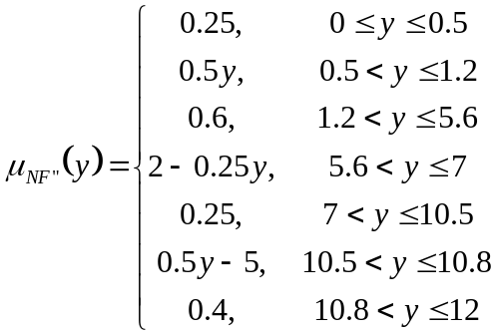
In Step #4, we might apply to this the continuous form of the COG defuzzification scheme. This could be expressed as follows.
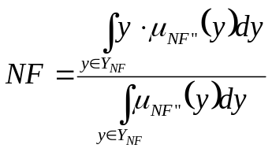
This way of stating the integrals is the most generally applicable, but a more conventional way to state the limits of these definite integrals for this specific case would be as 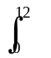. Obviously, it is not necessary to round to the nearest integer in this case, though we still would want to consider stating the final result only to an appropriate number of significant digits. If making the calculations manually, it certainly would be possible (and not even all that hard, though tedious) to determine the integrals analytically. Since for examples like this one, the membership function is piecewise linear, it might be quicker to calculate the denominator on the basis of geometrical areas. For the numerator, which might be described as piecewise quadratic, we still might use our basic skills at integral calculus.
However, if we were attempting to automate the calculations for a design like this on the computer, we might decide to settle for numerical approximations. This essentially would be taking us back to replacing the integral signs with summation signs. We might want to analyze how small the step sizes should be to give good approximations.

A Simple Trick for Dealing Easily with TFN-based Fuzzy Relations: First let me mention a technique that I have found very convenient, but which many might think of as a cheap trick or a hack. In defining fuzzy relations for the linguistic variables in many types of FIS applications (including basic fuzzy control) it is fairly common practice to have a graphical representation that looks something like this:
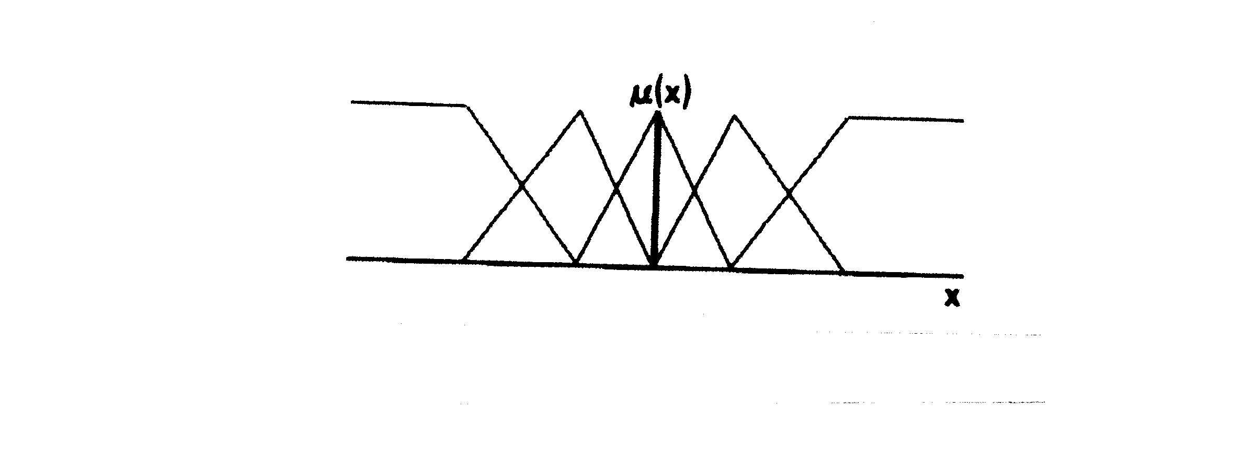
For example, in a control example, we might have the following fuzzy relation for one of the input variables.
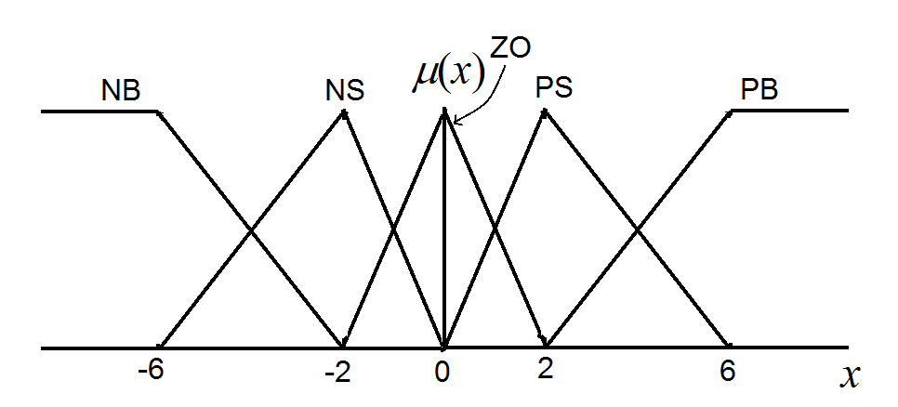
Note that the three intermediate terms (NS, ZO, and PS) all have TFN-type membership functions, but the extreme terms (NB and PB) don’t seem to fit the usual definition of a TFN. The membership function μ_{NB}(x) has the value of one for all x ≤ -6, and the same is true for μ_{PB}(x) for all x ≥ 6, so how can they be considered TFN’s? And if we have to treat them in another way (e.g. treat them as TrFN’s) and still treat NS, ZO, and PS as TFN’s, that will be kind of inconvenient, because it means that we’re mixing membership function forms within the same fuzzy relation. We could decide to treat all five linguistic terms as TrFN’s, but that would be kind of inconvenient too (messing around with four parameters instead of three for each term) if we don’t really have to do that. Well, this is why I wanted a solution to this situation even if it involved a cheap trick.
What we can do in the scenario above is state that all five linguistic terms take the form of TFN’s, by using the following parameters.

NB: (-∞, -6, -2)
NS: (-6, -2, 0)
ZO: (-2, 0, 2)
PS: (0, 2, 6)
PB: (2, 6, ∞)

Now, of course, we can’t truly represent -∞ or ∞ as floating point numbers, but what usually works just fine in most applications is in the constant declaration part of your program, define constants ninf = -10²⁰ and inf = 10²⁰, and then whenever you want to use -∞ or ∞ in your program, just use ninf or inf, respectively. Typically, this will work just fine for your application. For example, if you use the form to do the calculations, and you let the parameters be a₁ = ninf, a₂ = -6, and
a₃ = -2, you’ll get the right result for any reasonable value of x you put in. Try it out on your own for x = -10, -100, or even -1000. You’ll have the value of 1.0 or as close to it as you need to be anyway. This little trick makes programs easier to write sometimes and generally makes them easier to follow as well, even if it does seem like a dirty programming gimmick.

Enumerated Lists: Some of you with programming experience already know about enumerated lists. If you don’t, look the term up in the index of a manual for your favorite programming language. You might find it beneficial to understand how to use this idea in your favorite language for a variety of reasons that will come up in the future. In any case, it is a particularly convenient concept to know how to use if you want to write your own code for fuzzy logic applications. It will make your program both much more elegant to write and much easier to follow. Since the details of syntax vary from language to language, we’ll focus here only on the basic concept. Also, for ease of explanation, we’ll put a little less emphasis on using good structured techniques than we might in practice.
Let’s first take note of the traditional way of representing arrays and the traditional way of representing for loops in our programs. That is, traditionally we use an integer variable as an index for our arrays and loops. For example, if we would like to use a one dimensional array (let’s call it vect) with 5 slots, each holding some type of variable (such as a real value), we would probably first think of indexing the five slots by integer values, most likely 1, 2, 3, 4, and 5.

vect
1 2 3 4 5

To access the various values in this array, we would specify, for example vect[3] or more generally perhaps vect[i] where i is some value between 1 and 5.
And typically when we use a for loop, it would be indexed on some integer variable, such as i.

for i ← 1 to 5 do . . . .

This traditional way of doing things is fine most of the time, but sometimes it would be more convenient to have other options.
Suppose we would still like to have arrays and still like to have for loops, but index them according to some other type of labels, not just based on an integer variable. Let’s say we would like to have a 1D array, again with 5 slots, again with each slot holding a real value, but this time we’ll label the slots NB, NS, ZO, PS, and PB instead of 1, 2, 3, 4, and 5. Let’s call this array SEprime.

SEprime
NB NS ZO PS PB

To access the values in the array we could refer for example to SEprime[NS] , or more generally to SEprime[t], where t can take values of NB, NS, ZO, PS, or PB. Such an array might be useful for representing the fuzzy linguistic form of a particular variable. Furthermore, assume we could do a for loop based on the values in the list NB, NS, ZO, PS, and PB.

for t ← NB to PB do . . . .

It might also be useful to set up a 2D array, where for example the rows are labeled NB through PB, and the columns are labeled as integers (perhaps 1, 2, and 3) and suppose we called it RSE.

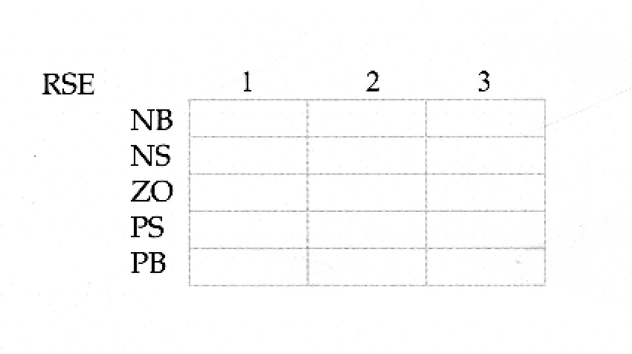
This array could be used to store all the parameters to represent the complete fuzzy relation for a linguistic variable (assuming that we pre-specify the general shape of the membership functions, as for example TFN’s). The columns might represent the a₁, a₂, and a₃ parameters in the case we are using TFN’s.
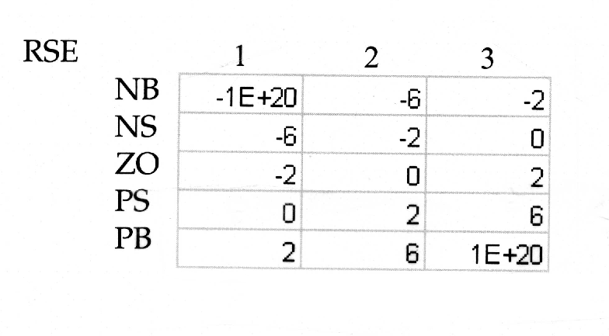

We can then refer to specific parts of this array in the code in the usual way. For example, RSE[NS, 2] would refer to the a₂ parameter for the term NS. More generally we can refer to RSE[t, i] where t takes a value from NB, NS, ZO, PS, or PB and i takes a value 1, 2, or 3.
We could, of course, have a 2D array where both the rows and columns are indexed based on a list of symbols. Interestingly, the rows and columns need not even be based the same list. More interesting still is that we can set up the array such that the entries in it can take the form of symbols from a list, and it might even be a third list, different from what we used for the rows and columns. Going back now to our fish-catch prediction system, we could set up the following array to represent the rules of the number-of-fish algorithm.

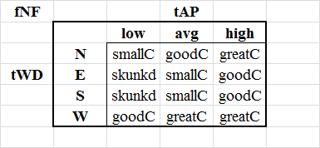

Naturally, in order to do all these things, you have to know how to set up various structures based on the enumerated list concept in the declaration part of your program. But this is typically not very hard to learn in the case of most modern programming languages, and it is worth learning it if it will make your programs much more elegant to write and to understand. This is particularly true for some types of fuzzy logic applications.

Implementing Steps #1 and #2: Let’s go back to the fish-catch prediction example to illustrate very briefly how we might implement Steps #1 and #2 as part of a program. The one extra tricky part here (usually not necessary) is that the membership function for north must be treated as a special case since the compass degrees wrap around. Assume that we’ve already done all the following:

- We’ve already input the crisp numerical values for WD and AP, and we’ve placed these in the two scalar real variables called, naturally enough, WD and AP.
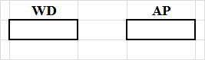
- Based on the enumerated list concept, we’ve set up the 3 scalar variables:
- tWD (which can take the values N, E, S, or W)
- tAP (which can take the values low, avg, or high)
- tNF (which can take the values Dskunkd, smallC, goodC, or greatC)
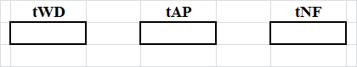
- Also based on enumerated lists, and similar to what we did in the previous section, assume we’ve set up two 2D arrays (with five rows and three rows, respectively; and each with four columns) to represent all the TrFN parameters (a₁, a₂, a₃ and a₄) that we need to represent the input fuzzy relations, and we’ve called these RWD and RAP. (Unfortunately, once again this is extra tricky because of north.)
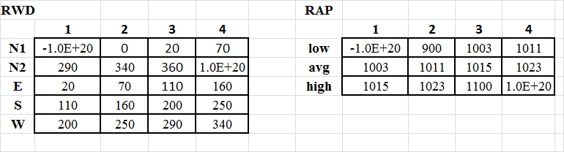
- We’ve defined 1D arrays to hold the fuzzy linguistic forms of the two input and one output variables, and we call these WDprime, APprime, and NFprime.
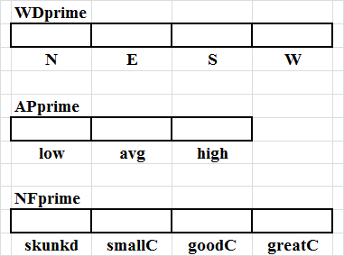
- Also similar to what we illustrated in the previous section, we’ve set up a 2D array to represent the number-of-fish algorithm, and we’ve called this fNF.
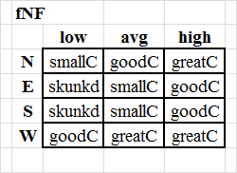
- We’ve defined a function (as a subprogram) that calculates the membership grade for a TrFN, given that we pass it an x value along with the four parameters a₁, a₂, a₃ and a₄. We call this muTrFN(x, a1,a2,a3,a4).
- We also have two very simple functions min and max which return the minimum (or maximum) of two values.

Assuming we have all that, the code for Steps #1 and #2 is easy. Step #1 can be just a few lines of code:

WDprime[N] ← max(muTrFN(WD, RWD[N1,1],RWD[N1,2], RWD[N1,3],RWD[N1,4]),
muTrFN(WD, RWD[N2,1],RWD[N2,2], RWD[N2,3],RWD[N2,4])) ;
{Note: This special step was necessary for north.}
for tWD ← E to W do WDprime[tWD] ← muTrFN(WD, RWD[tWD,1], RWD[tWD,2],
RWD[tWD,3], RWD[tWD,4]) ;
for tAP ← low to high do APprime[tAP] ← muTrFN(AP, RAP[tAP,1], RAP[tAP,2],
RAP[tAP,3], RAP[tAP,4]) ;

Step #2 is a little trickier. Remember that under the standard fuzzy logic operators we end up taking the maximum of the several minima that relate to each term for each of the outputs. We can start by initializing the NFprime array to zeros, and then going through the rule tables in order.

for tNF ← skunkd to greatC do NFprime[tNF] ← 0.0 ;
for tWD ← N to W do
for tAP ← low to high do
begin
thismin ← min(BPprime[tBP], WSprime[tWS]) ;
if thismin > NFprime[fNF[tWD,tAP]] then NFprime[fNF[tWD,tAP]] ← thismin;
end ;

Implementing Steps #3 and #4: As suggested above, even if we did have continuous numerical value spaces for the output variable(s), we’d probably still want to use a discrete approximation rather than trying to write a program that would perform the integrals in an analytical way. If we already have discrete (and finite) numerical value space(s) for the output(s), this isn’t even an issue. In any case, let’s focus for now what we need to do for our relatively simple example of fish-catch prediction.
First, concerning data structures, assume we have everything we laid out for Steps #1 and 2, and a few more things besides. First, since we can continue to assume a trapezoidal fuzzy number format for the fuzzy relations, we’ll have a 2D array called RNF which will be similar in layout to what we had for RWD and RAP above.
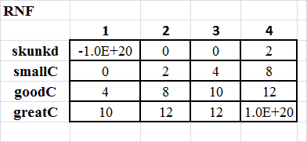
Also, assume that we have a 1D called NFdoubleprime. This array is a little more traditional than what we had above in that they are indexed by the integers from 0 to 12 (most modern languages allow the indexing on arrays to start at 0 rather than at 1 when that is desirable). The 13 slots in this array can hold real values.
For Step #3, the trick will be to think of each possible value of y in turn and figure out what the Max-min rule tells us to do for each. (Even though this may be a bit of a sloppy programming practice, let’s assume for now that we are treating y as an integer scalar variable so that we can easily use it to index the double-prime arrays.) The Max-min rule is based on taking the maximum of several minima, so again we will use the trick of initializing to zero and then bumping up when we get a minimum that is greater than what we already have for a given slot. We’ll just show the part here for the number-of-fish variable.
for y ← 0 to 12 do
begin
NFdoubleprime[y] ← 0.0 ;
for tNF ← skunkd to greatC do
begin
mu ← muTrFN(y, RNF[tNF,1], RNF[tNF,2],RNF[tNF,3], RNF[tNF,4]) ;
thismin ← min(NFprime[tNF], mu) ;
if thismin > NFdoubleprime[y] then NFdoubleprime[y] ← thismin ;
end ;
end ;

For Step #4, the design directs us to use the discrete version of the COG defuzzification method as already discussed.
So we could implement Step #4 here in the following way.
denominator ← 0.0 ; numerator ← 0.0 ;
for y ← 0 to 12 do
begin
denominator ← denominator + NFdoubleprime[y] ;
numerator ← numerator + y * NFdoubleprime[y] ;
end ;
CR ← integer(numerator/denominator + 0.5) ;

That’s all there is to it. (It is a common phenomenon in programming the methodologies we cover in soft computing, that if the data structure are set up properly, implementing the algorithms is actually pretty easy.) If instead of writing code, you implement your projects in a spreadsheet format, then that is also pretty easy, easier than most methodologies in fact.

